AWARD-WINNING R&B ARTISTS, TAMIA AND JOE, SET TO PERFORM AT SHEA’S PERFORMING ARTS CENTER ON MARCH 30
General On Sale Begins Friday, December 8 at 10 a.m. Local Time on Ticketmaster.com
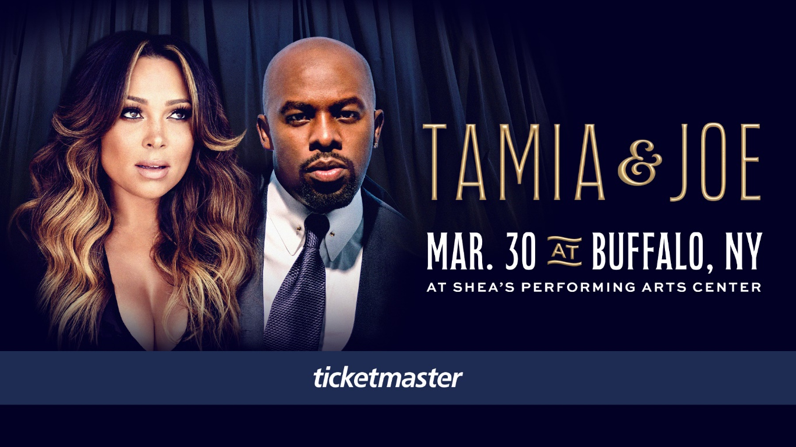

BUFFALO, N.Y. (December 1, 2023) – Prepare for a night of soulful melodies and captivating performances by award-winning artists, Tamia and Joe, as they perform at Shea’s Performing Arts Center on March 30. Featuring six-time Grammy-nominated R&B sensation, Tamia, and the smooth vocal stylings of Joe, this special event promises to be a memorable celebration of musical excellence, showcasing two of R&B most renowned artists.
Tickets are available for pre-sale starting Wednesday, December 6 at 10 a.m. local time. General on sale begins Friday, December 8 at 10 a.m. local time at Ticketmaster.com.

Tamia, a chart-topping artist with a career spanning over two decades, continues to captivate audiences with her soulful voice and timeless hits. With Grammy nominations and numerous awards under her belt, Tamia is considered a force in the R&B genre, delivering performances that resonate with fans around the globe.
Joe, acclaimed for his velvety vocals and chart-topping R&B classics, will bring his signature style to the stage. With a career marked by hit singles like "All the Things (Your Man Won't Do)" and "I Wanna Know," Joe has solidified his status as an R&B icon, earning him critical acclaim and a dedicated fan base.

The Tamia & Joe Tour is produced by North American Entertainment Group Inc., one of the leading independent promoters of entertainment tours and live events in the United States.
SHOW DETAILS DATES:
Date: March 30, 2024
Time: 8:00 p.m.
Venue: Shea’s Performing Arts Center, 646 Main St, Buffalo, NY
Ticket Prices: $69, $79, $99, $125, $175 (not including taxes and fees)
Ticket Link: https://www.ticketmaster.com/event/00005F7BA12D25EA
Presale Code: TJ2024
ABOUT NORTH AMERICAN ENTERTAINMENT GROUP:
North American Entertainment Group, Inc. is one of the largest independent promoters of entertainment tours and live events in the United States. With more than 25 years in the industry and an extensive history in venue management, NAEG has consistently delivered the hottest concerts, comedy shows and theatrical entertainment to venues in more than 100 markets. Beyond the stage, NAEG has produced television specials, concert DVD’s, online content and branded merchandise. A company distinguished by creativity in tour packaging and marketing strategy, NAEG’s success resounds in the memories of those who have attended their events. North American Entertainment Group is an umbrella company of several popular, hit subdivisions. With experience in all types of entertainment (comedy, hip hop, jazz and more), North American Entertainment Group is always searching the horizon for pinnacles of new entertainment to deliver to cities around the country. For more information, visit northamericanentertainment.com

MEDIA CONTACT:
Amy Sisoyev | Sisoyev Public Relations | Amy@SisoyevPR.com

###

